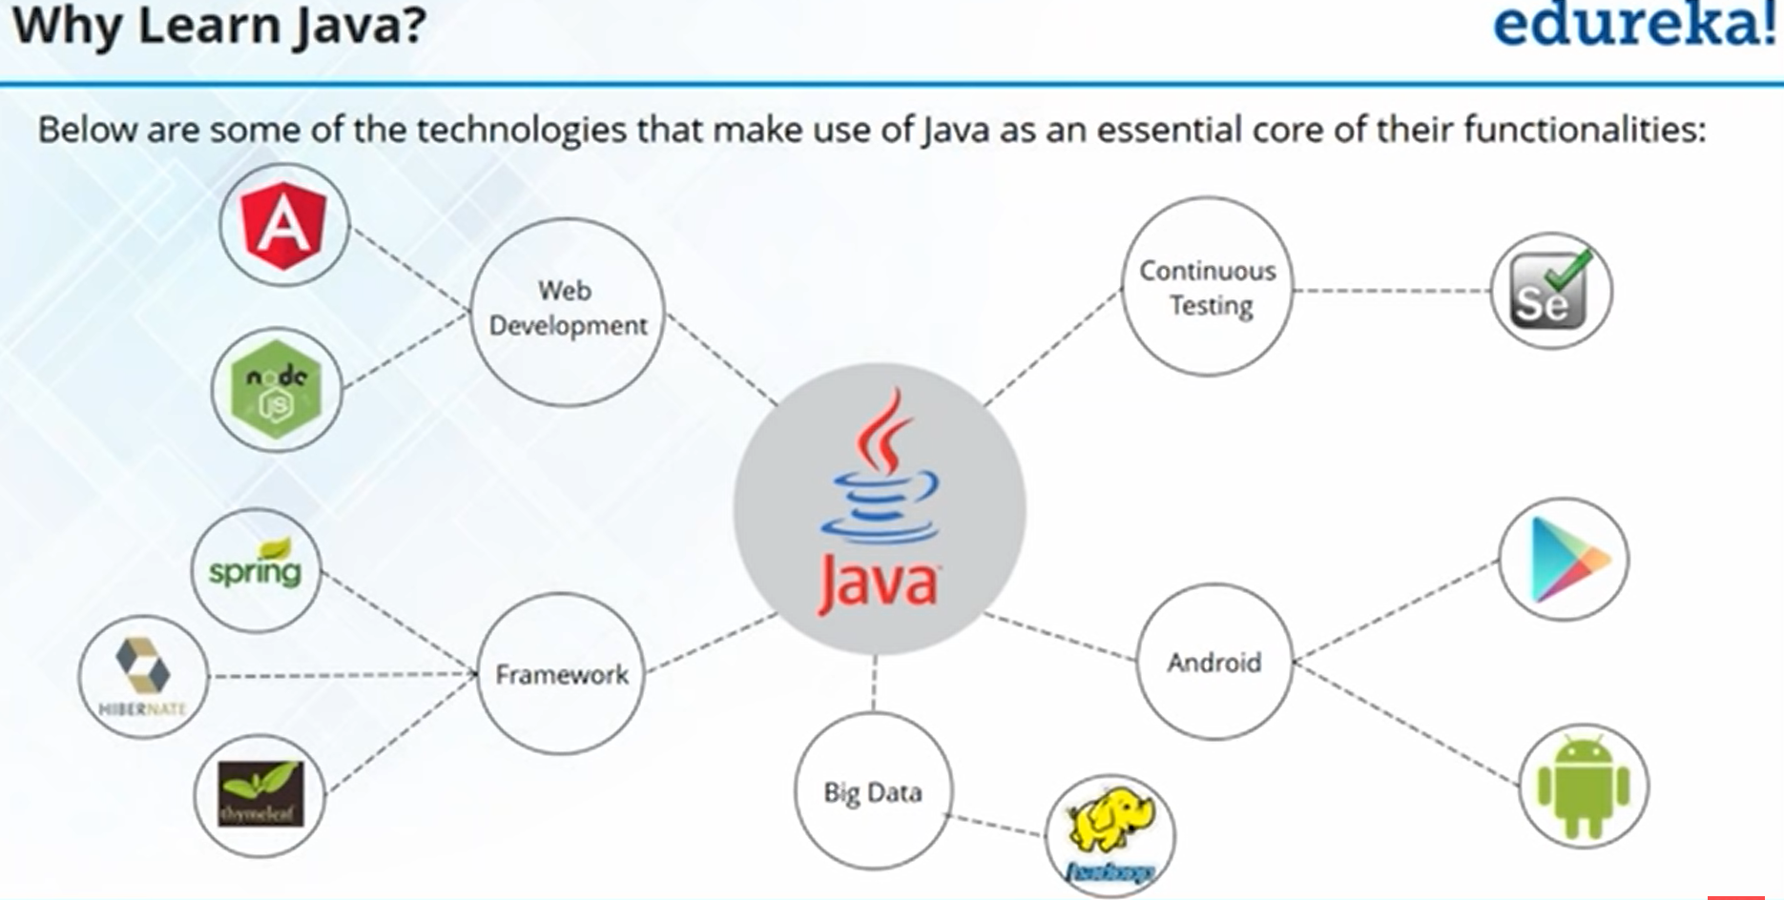



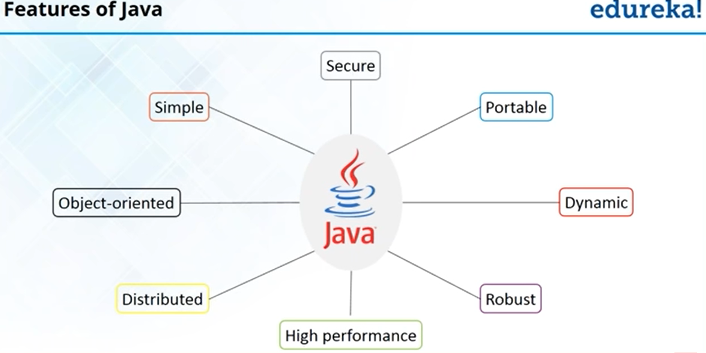



Simple – Java was designed to be easy for professional programmer to learn and use effectively.

Portable – Applications written on one platform can be easily ported to another platform as it is platform independent. Example: Windows to Safari, Ubuntu, Solaris, redhat etc.,

Object oriented- Java is an object oriented programming language. Everything is considered to be an “object” and all operations are performed using these objects.

Secure – Java does not use explicit pointer and runs its programs inside the sandbox to prevent any activities from untrusted resources.

Distributed – Java has a feature called Remote Method Invocation(RMI) using which a program can invoke method of another program across a network and get the output.

Dynamic – Java programs carry with them substantial amounts of run time type information that is used to verify and resolve accesses to objects at run time.

Robust – Java checks the code during the compilation time and run time also. Java completely takes care of memory allocation and releasing, which makes the java program more robust.

High Performance – Java achieves high performance through the use of bytecode which can easily translated into native machine code.

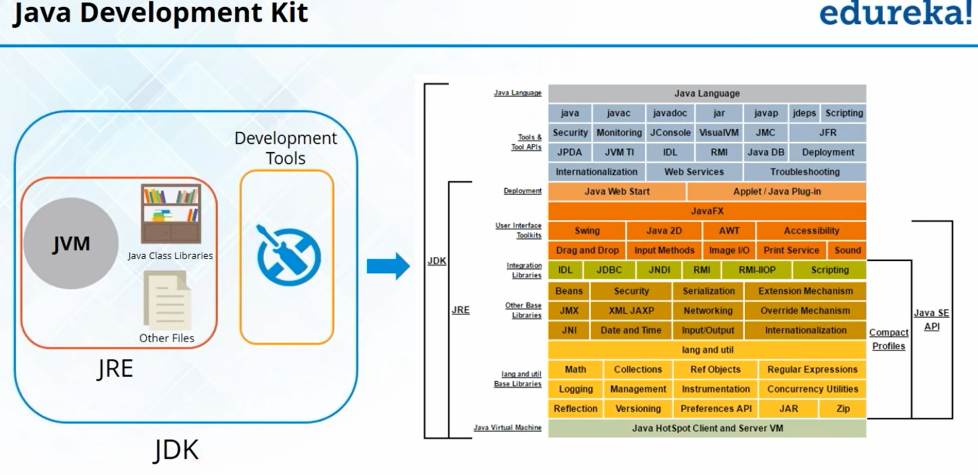



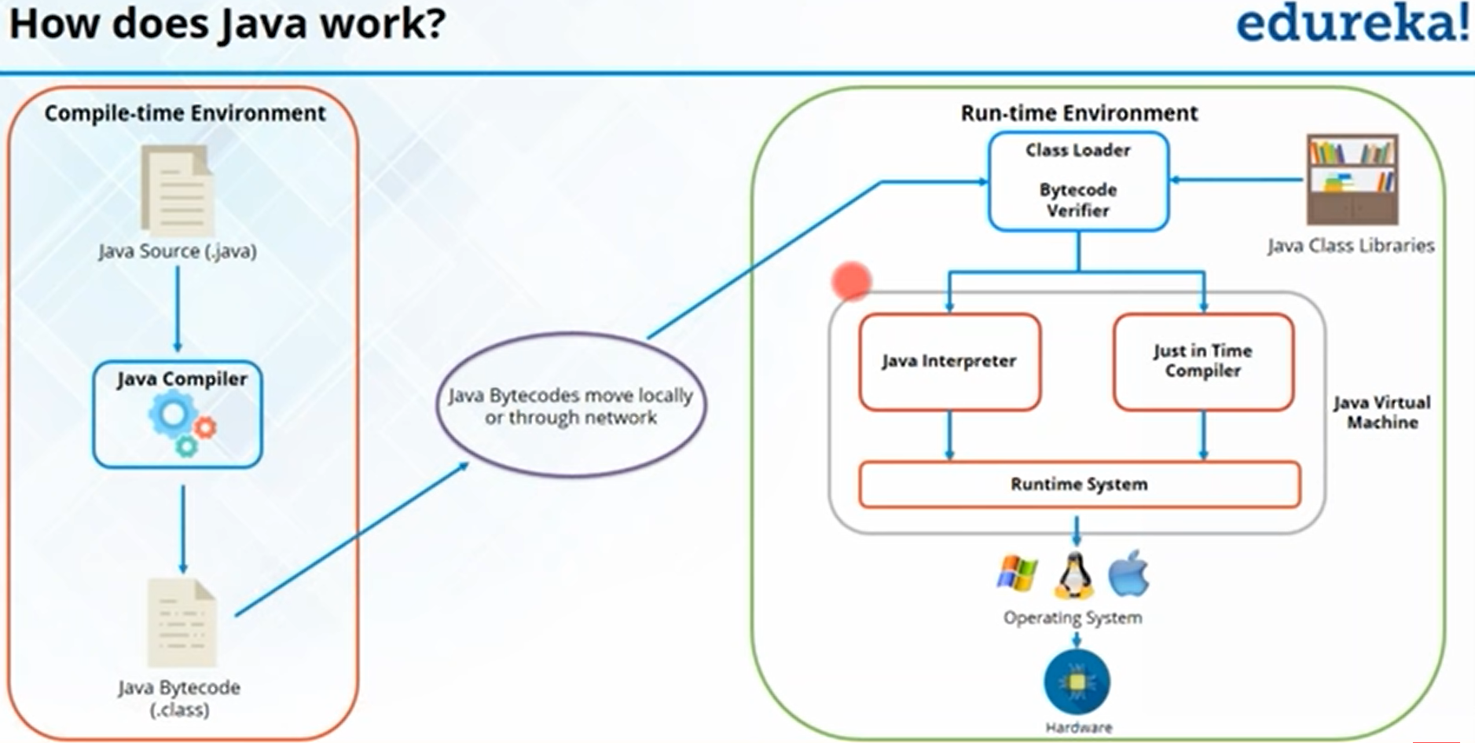



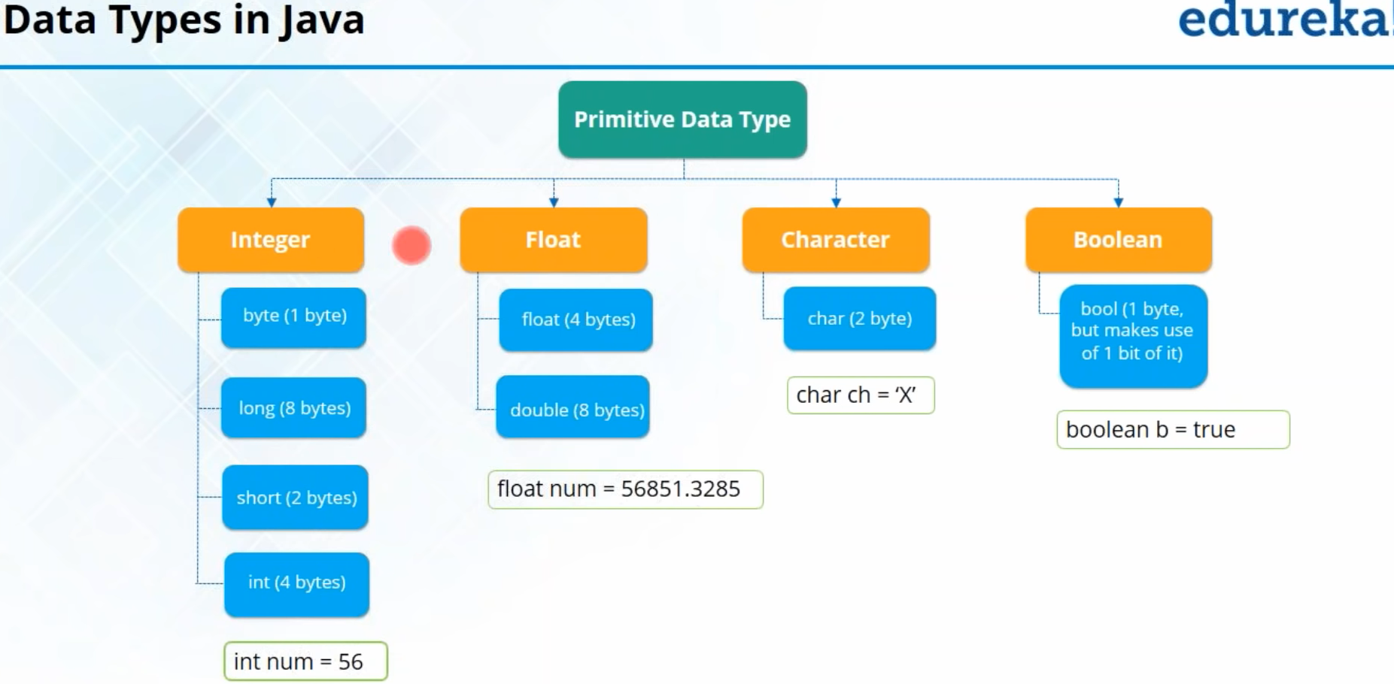



For example

In Retail Departmental store, you need to create a bill with following fields present. Can you guess what are the data types to be used for the below fields?

Invoice ID, Product ID, Product Cost, Quantity, Discount, Total Price, Feedback provided or not? etc

Ans: Integer, Integer, Double, Integer, Double, Double, Boolean

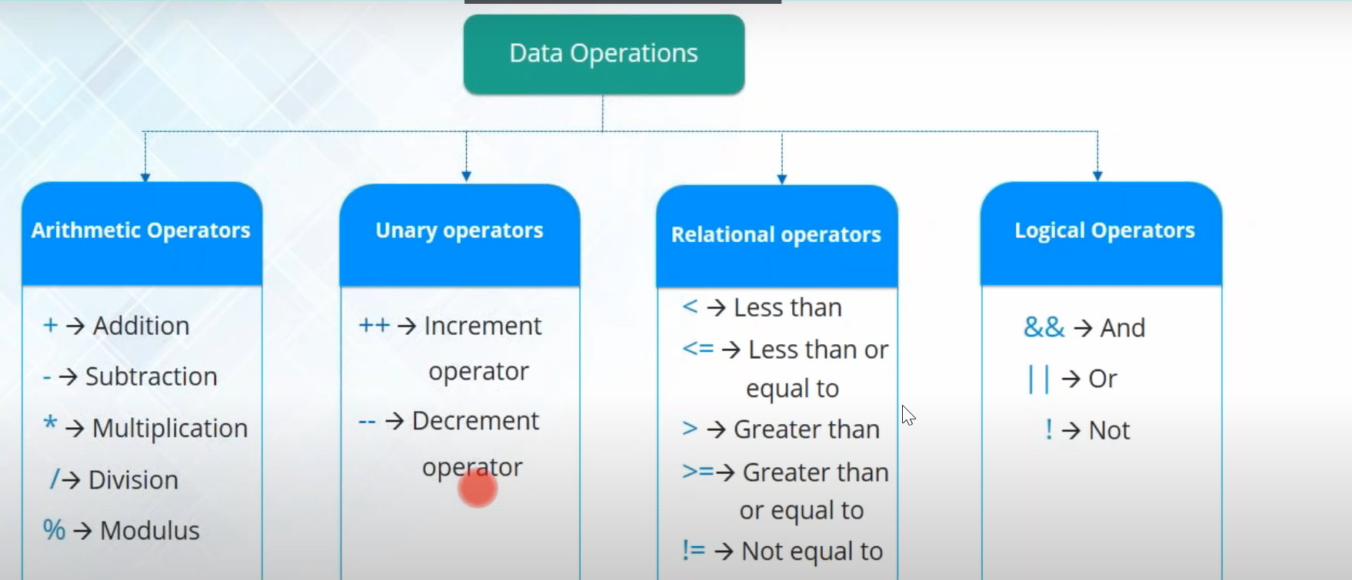

For Example, Let us assume following values for the variables

Num 1 = 10, Num 2 = 15, Num 3 = 25, Num 4 = true

Can you guess what is the output of the below operations?

(Num1+Num2)-Num3/5

Num1++

Num3 >= Num1 + Num2

Num2 == Num1

(Num2 < Num3) && (Num1 > Num3)

!Num4

Ans:

20, 11, True, False, False, False

Control Statements

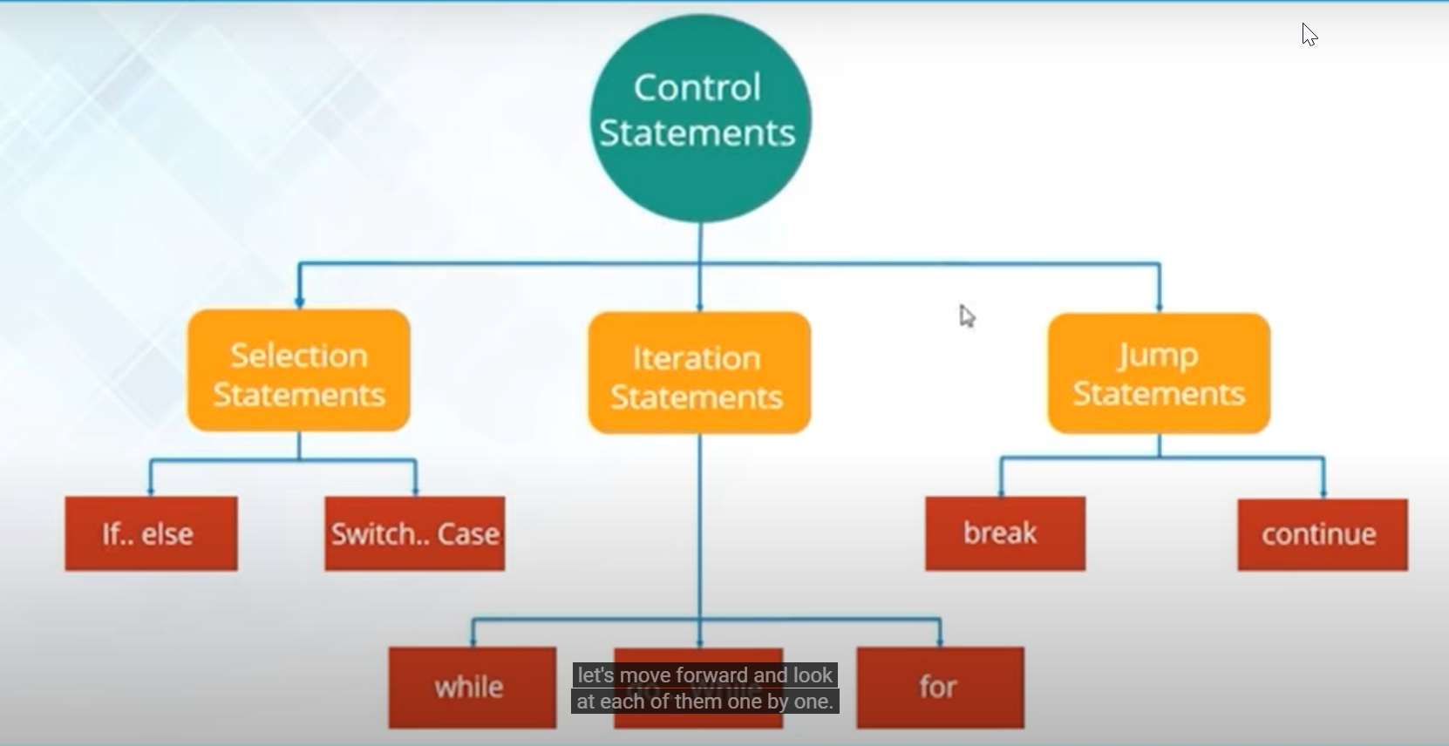

If(condition):

{

Statement 1;

}

else:

{

Statement 2;

}

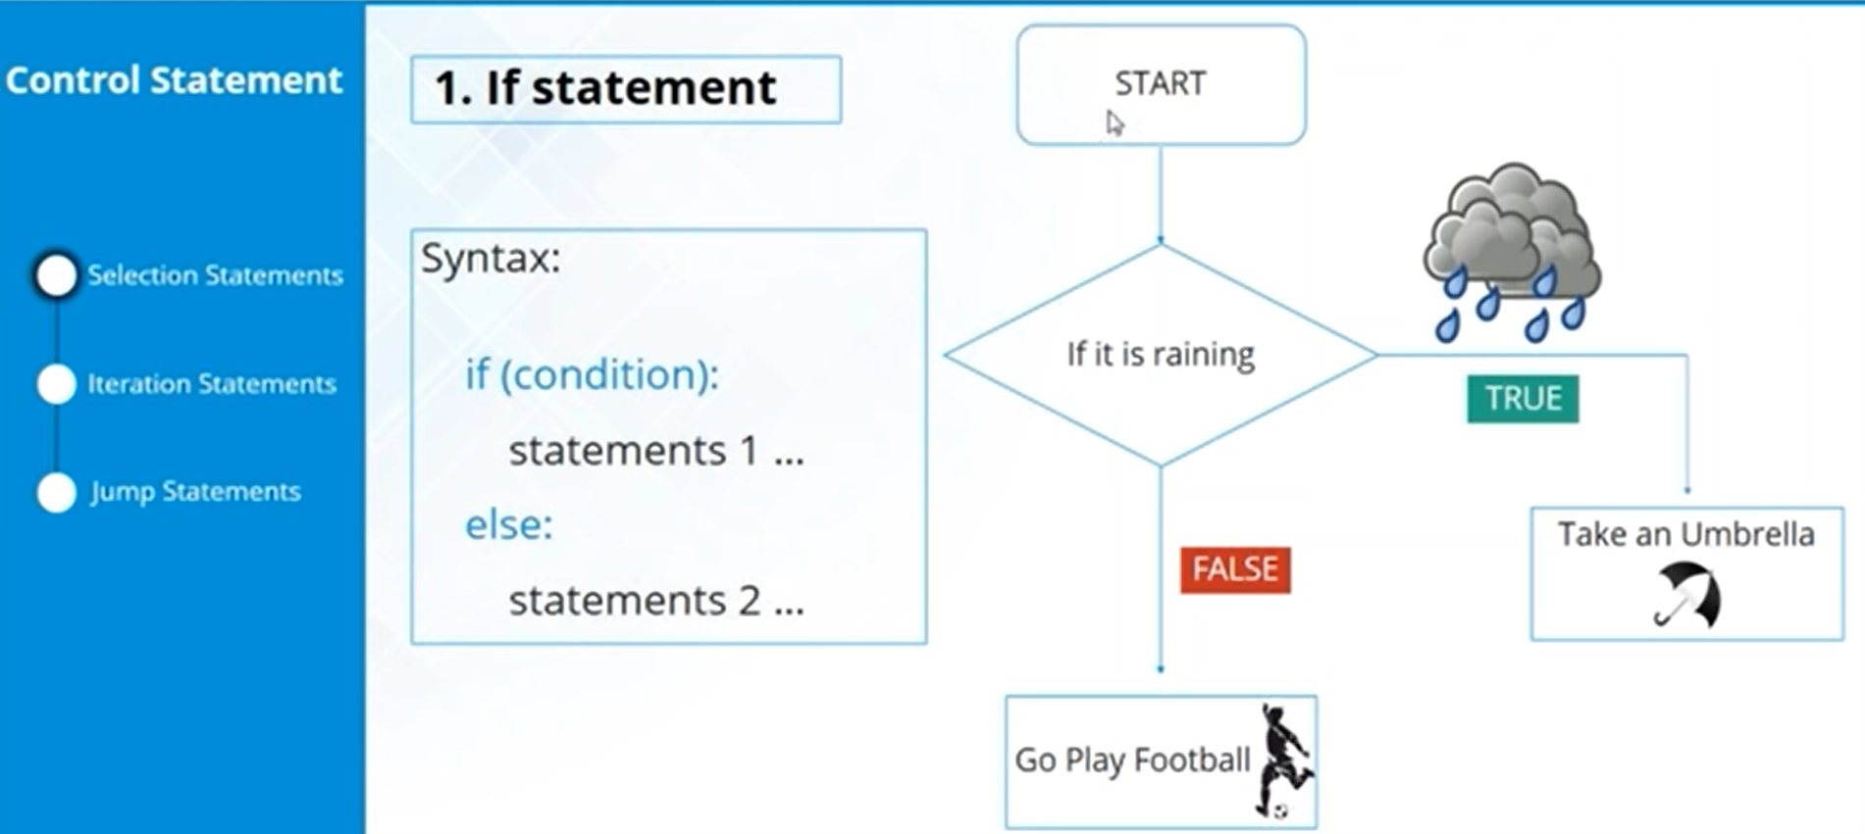

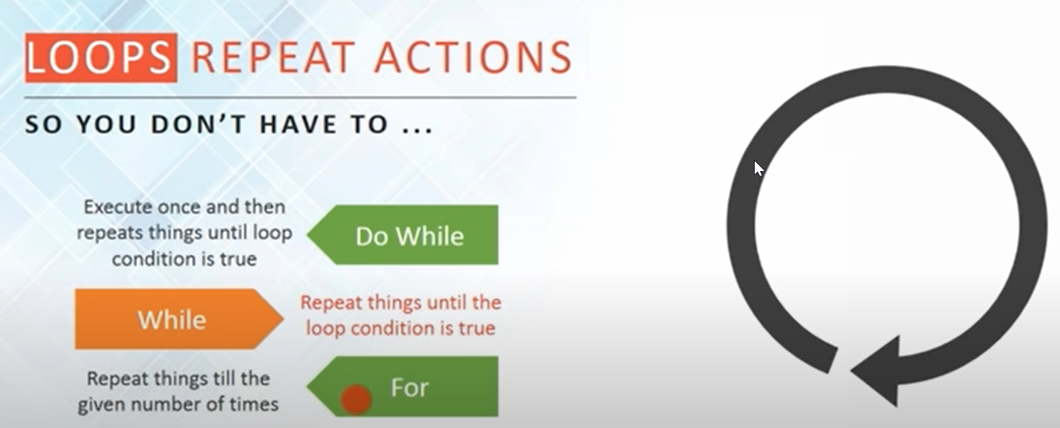

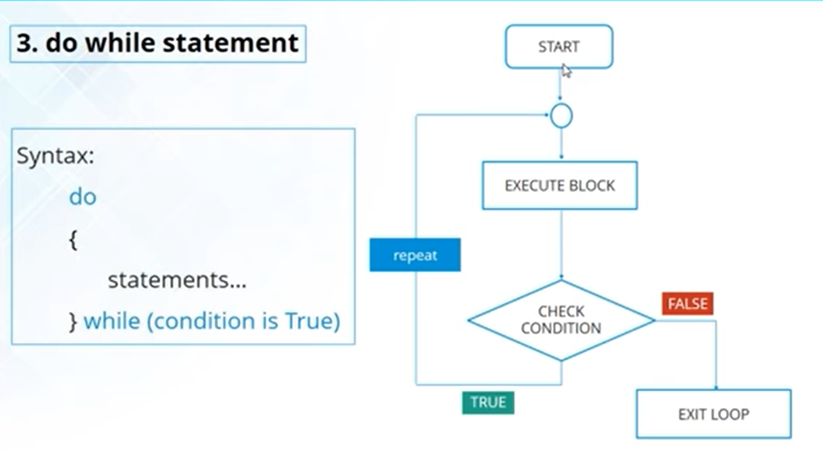

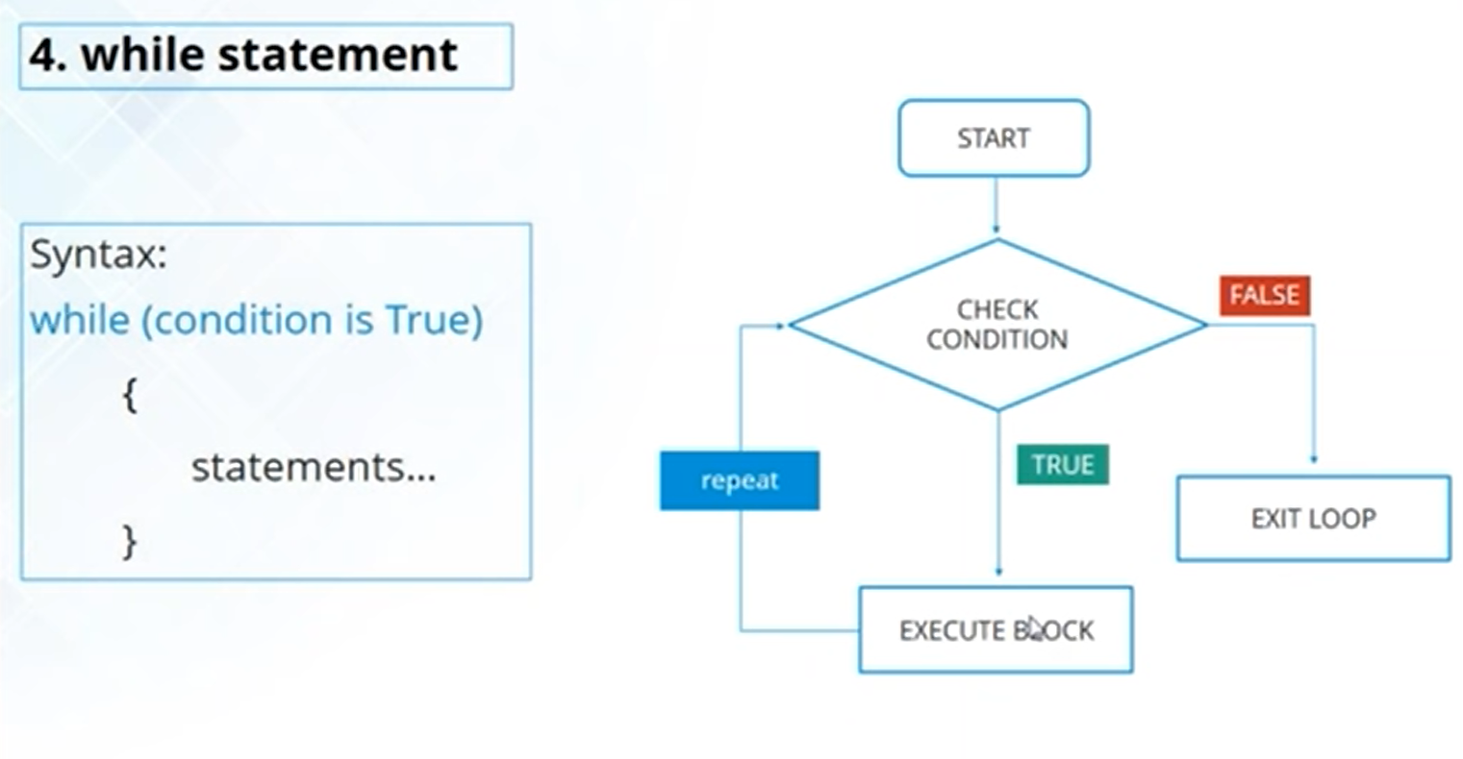

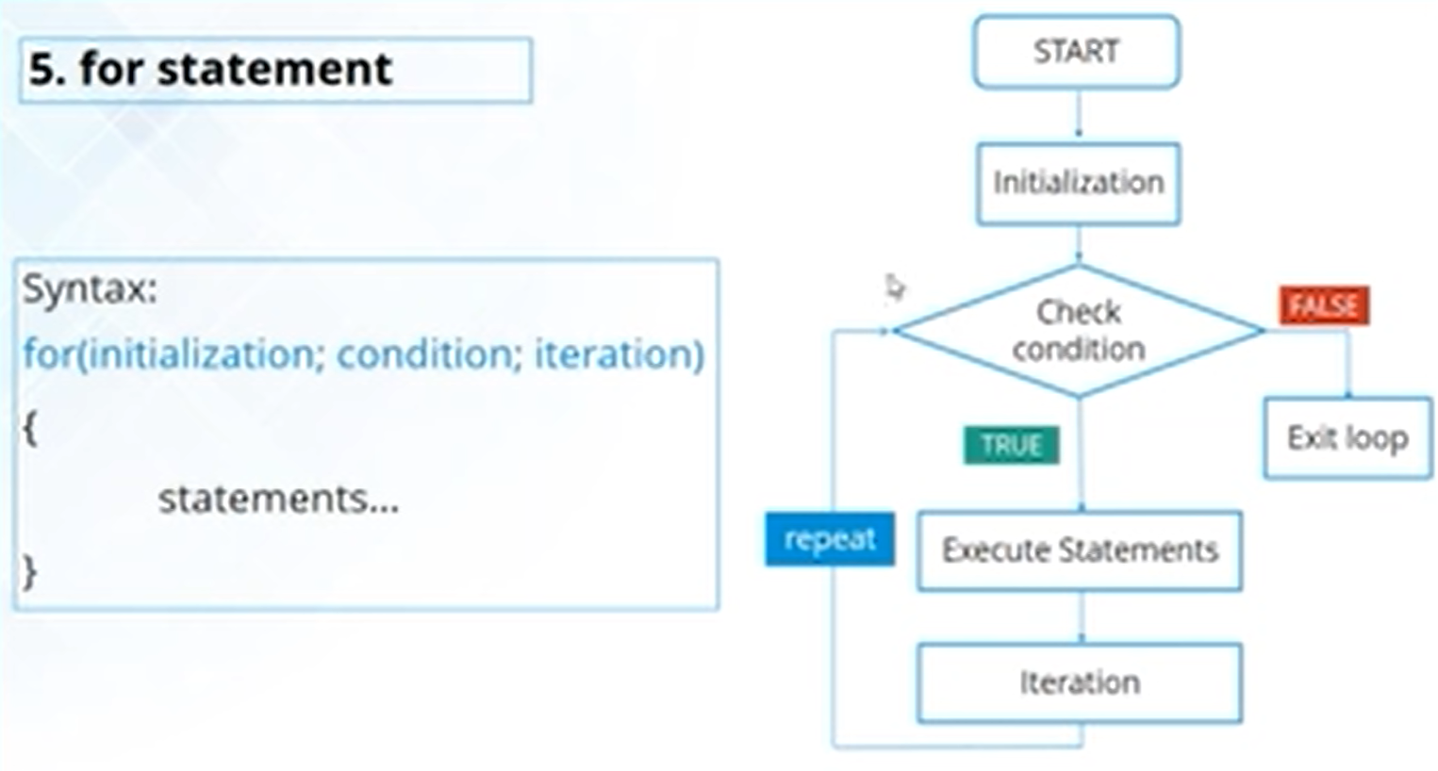

Non Primitive Data types- Array, Class, Object,

Example : Roll numbers of students in a class to be stored in single variable. Then we need Array

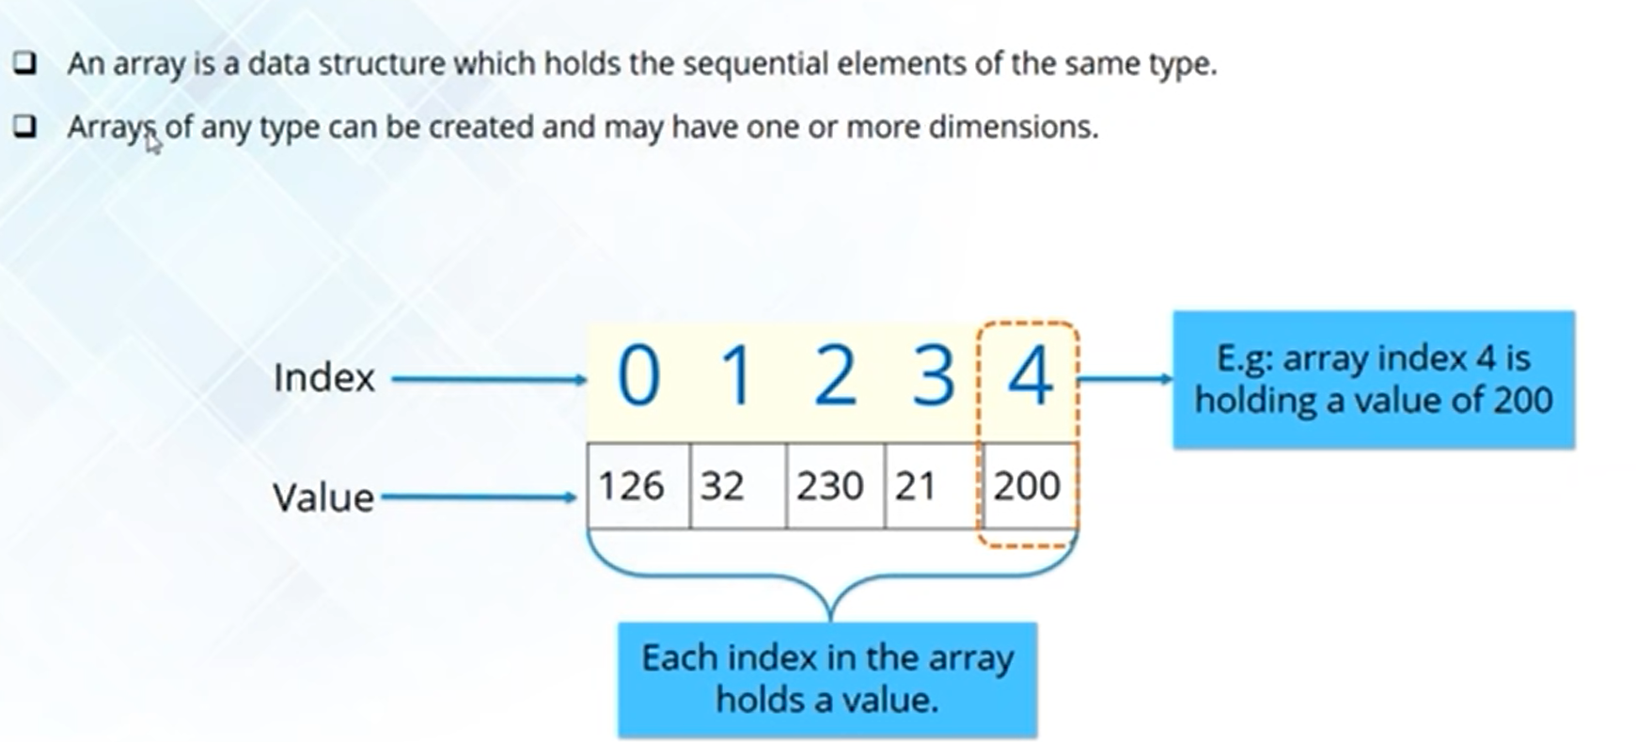

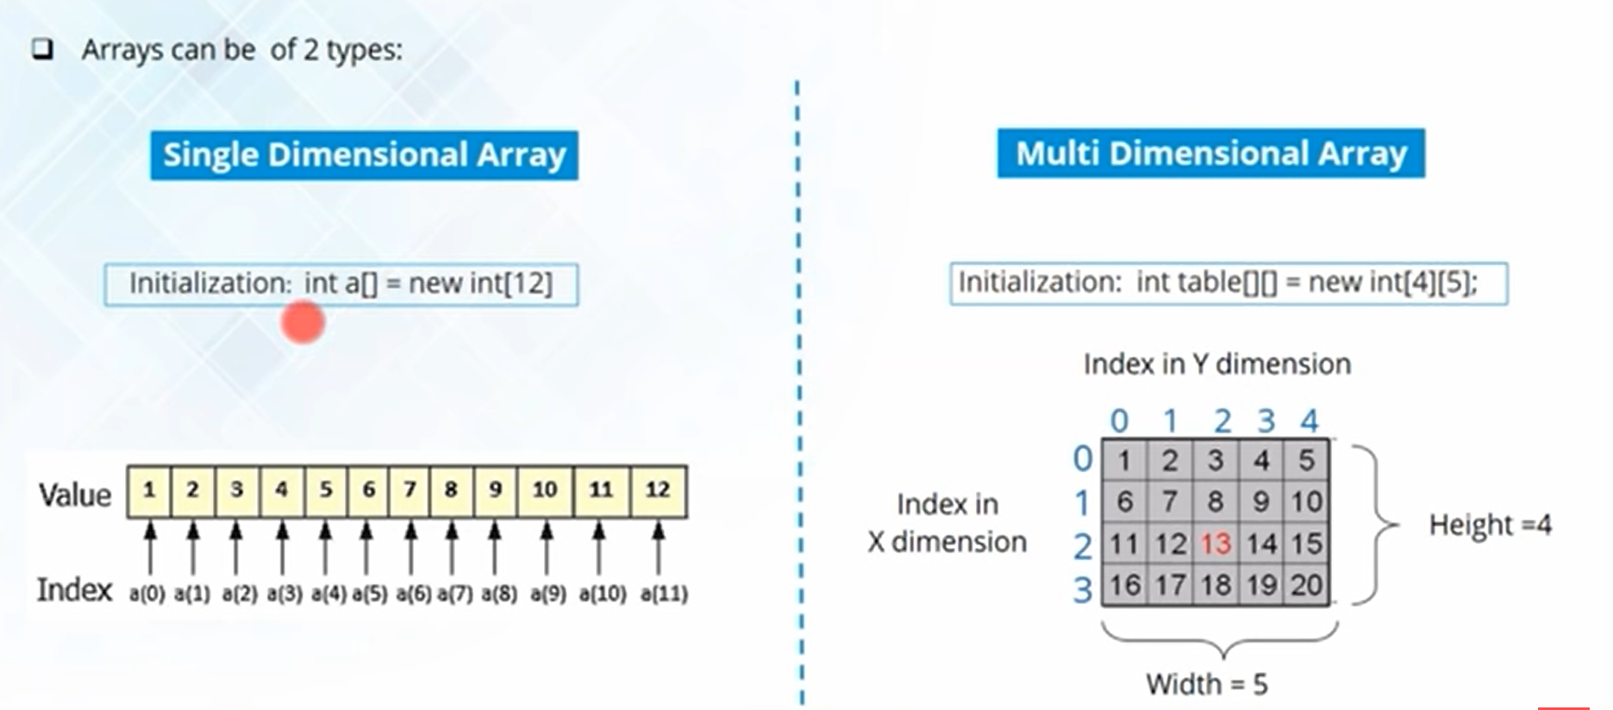

Syntax:

Public static void main(String[], args)

{

}

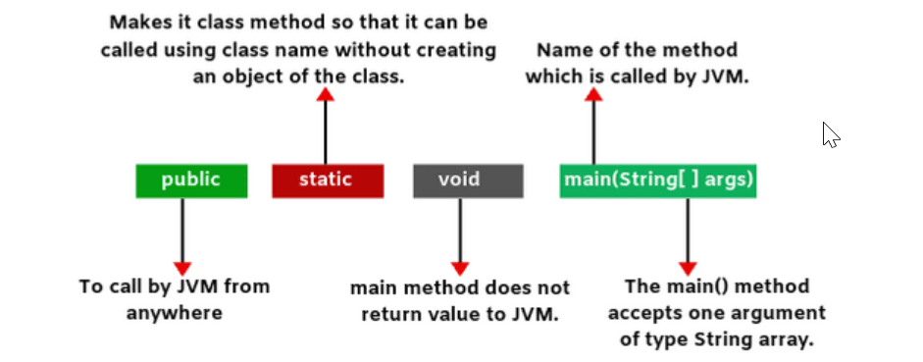

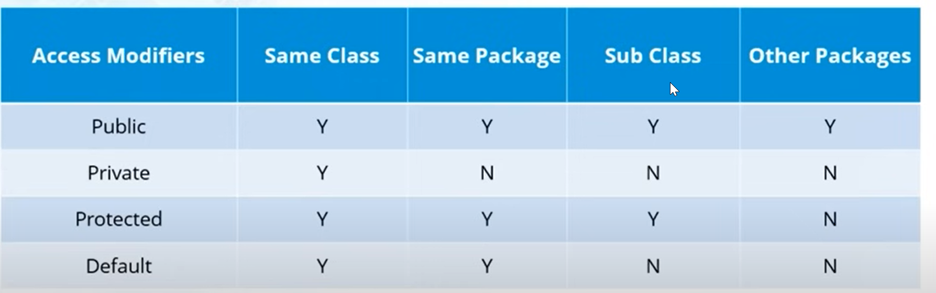

Public, Protected, Default, Private

Static Keyword - javatpoint

this Keyword - javatpoint

Java Basics

<https://www.youtube.com/watch?v=aqHhpahguVY>

https://www.scientecheasy.com/2020/06/main-method-in-java.html/

<https://www.youtube.com/watch?v=hBh_CC5y8-s&t=15435s>